**Name:- Dharan Gowda Superset id:-6387532**

**1. Create React App**

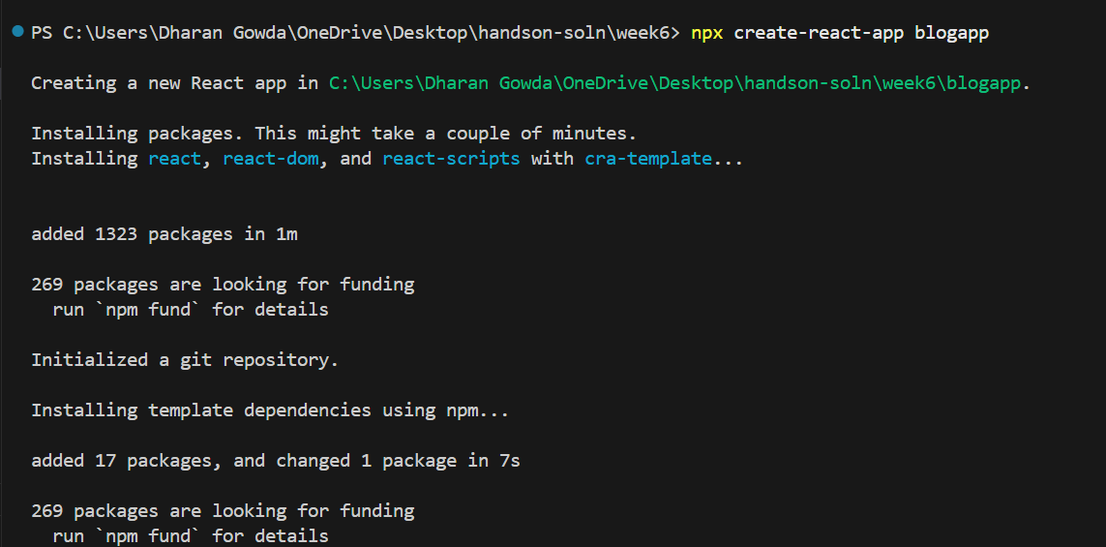

**2. Create Post.js (Model Class for Post)**

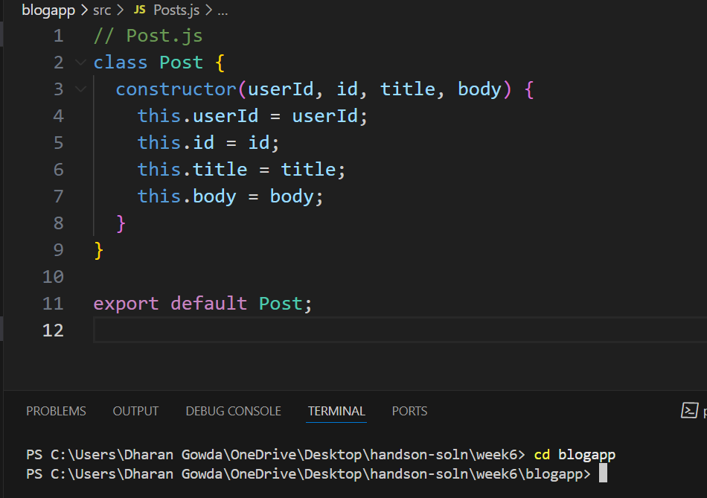

**3. Create Posts.js (Class Component)**

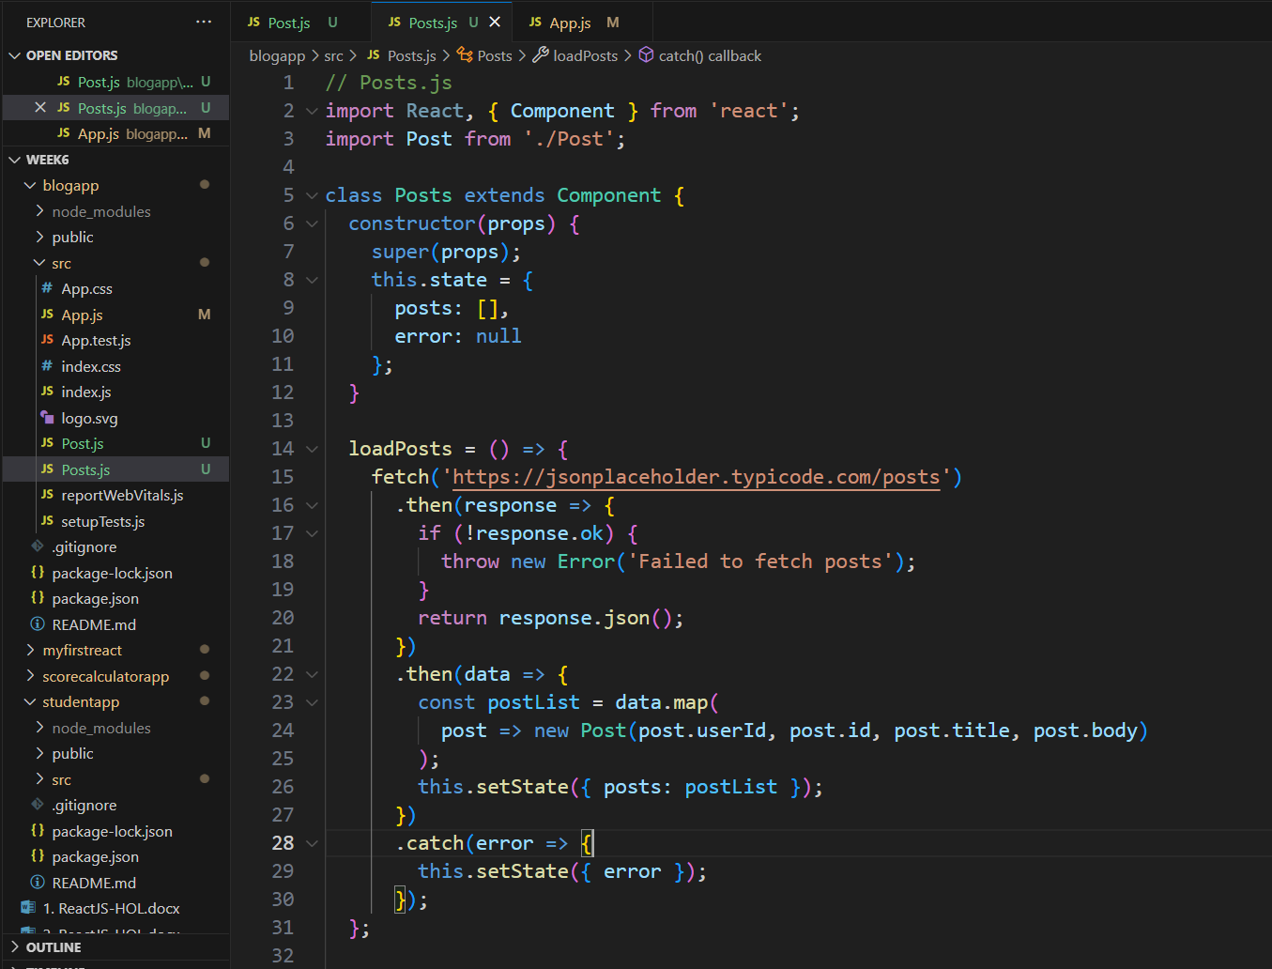

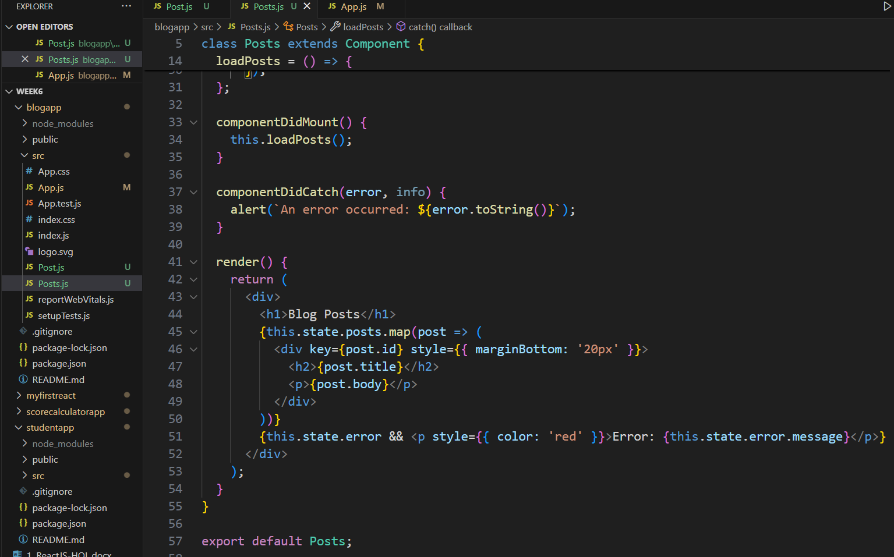

**4. Update App.js to include Posts component**

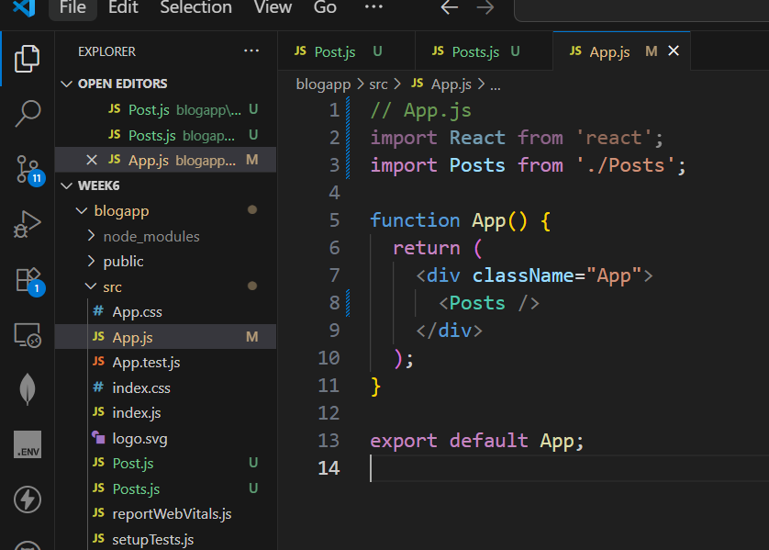

**5. Run the Application** 